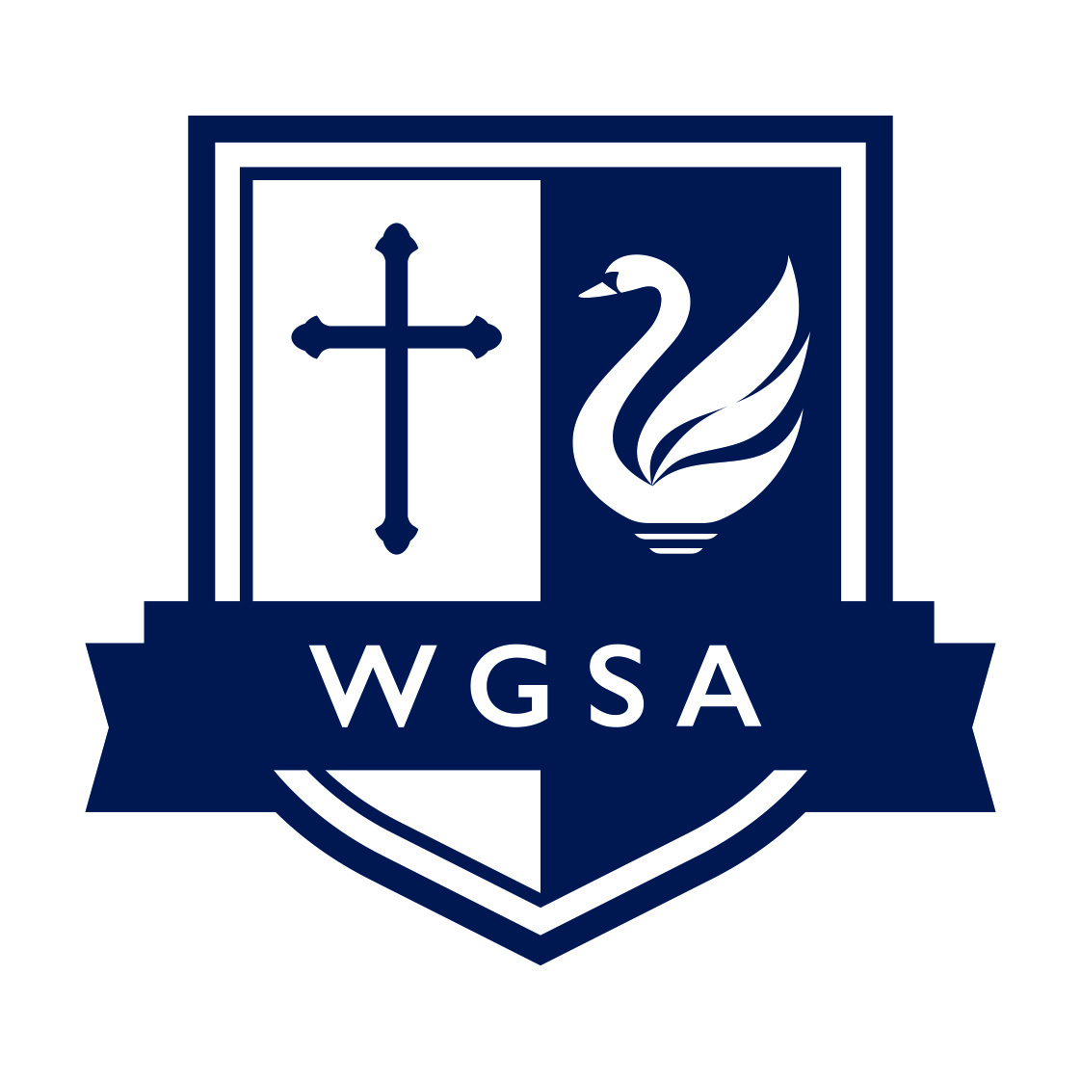
LEARNING SUPPORT CO-ORDINATOR
Grade 4, Point 8 – 14 (pro rata £22,332 - £24,593)
Starting as soon as possible. Permanent contract for 37 hours per week, 39 weeks per year
The West Grantham Church of England Secondary Academy seek to appoint a Learning Support
Co-ordinator.
The purpose of the role will be to:
- Provide short-term and longer-term intervention programmes to support students to engage in learning, with the longer-term aim of enabling all students to be successful in their mainstream classrooms. This may involve some in-class support
- To plan and prepare lessons for students attending the outdoor learning provision. To ensure that lessons engage students in learning – outside learning lessons and classroom-based learning.
- Support students to develop skills to be successful: resilience, perseverance, problem-solving, teamwork and communication skills.
The successful candidate will have a proven track record in working with young people and the ability to see a young person’s needs from a range of perspectives. It is essential that they possess a good working knowledge of safeguarding, excellent interpersonal and communication skills and can prepare and implement risk assessments.
Here at West Grantham Secondary Academy, awarded Good with Outstanding features by Ofsted in January 2024, we continue to provide a place of work that is proudly able to offer the following:
- A community school where staff and students are friendly and welcoming
- An intake that has increased over four years, yet is still a small family school
- A school that has undergone significant change and improvement
- Excellent behaviour and pastoral support for the whole child
- A focus on staff wellbeing and belonging
Alongside this, we can also provide:
- An electric car work scheme
- Staff assistance programme
- Free breakfast and lunch for staff

More information and application forms are available on our website: https://www.wgacademy.org.uk/vacancies/

Please submit completed support staff application forms to Estelle Sharpe by email: esharpe@wgacademy.org.uk.

Application deadline: 11:59pm on Sunday 8 June 2025
Interview date: TBC

The Diocese of Southwell and Nottingham Multi Academy Trust is committed to safeguarding and promoting the welfare of young people and expects all employees to share this commitment. The successful applicant will be subject to appropriate child protection screening including checks with previous employers and undertake an enhanced DBS with barred check.


