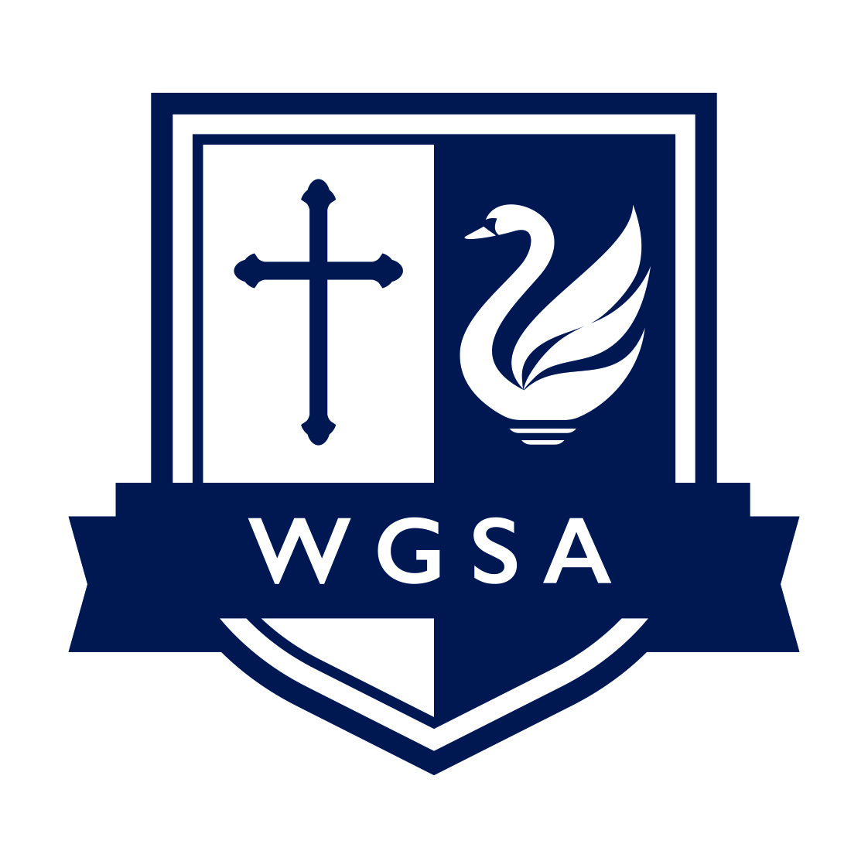
TEACHING ASSISTANT LEVEL 1

Start Date: 1 September 2025
Contract: Part-time, permanent
Pro rata salary: £18,708 to £19,308

The West Grantham Church of England Secondary Academy has a vacancy for a Teaching Assistant Level 1. The post holder will be required to work 32.50 hours per week for 39 weeks per year. As part of this role, the successful candidate will:
- Work with class teachers to raise the learning and attainment of pupils
- Promote pupils’ independence, self-esteem and social inclusion
- Give support to pupils, individually or in groups, so they can access the curriculum, take part in learning and experience a sense of achievement.
We are looking for a Teaching Assistant who is:
- An excellent practitioner committed to high standards for all children.
- Ideally, has experience of working with children with social and emotional needs
- Has high expectations of the children in terms of behaviour and learning
- Is a good team player
- Has a creative approach to teaching and learning
- Has the determination to make school life a positive, rewarding and enjoyable experience for everyone
Here at West Grantham Secondary Academy, awarded Good with Outstanding features by Ofsted in January 2024, we continue to provide a place of work that is proudly able to offer the following:
- A community school where staff and students are friendly and welcoming
- An intake that has increased over four years, yet is still a small family school
- A school that has undergone significant change and improvement
- Excellent behaviour and pastoral support for the whole child
- A focus on staff wellbeing and belonging
Alongside this, we can also provide:
- An electric car work scheme
- Staff assistance programme
- Free breakfast and lunch for staff

More information and application forms are available on our website: https://www.wgacademy.org.uk/vacancies/

Please submit completed applications to Estelle Sharpe by email: esharpe@wgacademy.org.uk. Please note that we cannot accept CVs as a form of application.

Application deadline: 11:59pm on Wednesday 4 June 2025
Interview date: TBC

The Diocese of Southwell and Nottingham Multi Academy Trust is committed to safeguarding and promoting the welfare of young people and expects all employees to share this commitment. The successful applicant will be subject to appropriate child protection screening including checks with previous employers and undertake an enhanced DBS with barred check.
