

**St Mary Magdalene C of E Primary School**

Acting Headteacher: Mrs S Pearson

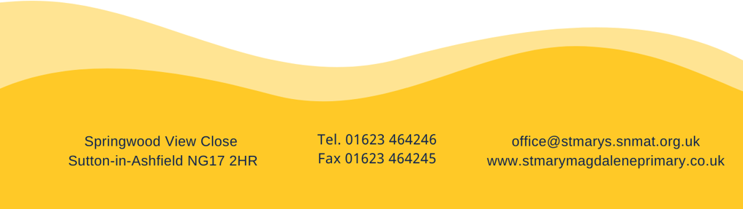

**Vacancies:** Grade 3 TA

**Contract:**  Permanent 37 hours per week TTO

Actual Salary £21,980 – £22,684

Are you passionate about improving the lives and outcomes of children? We are! Every child needs a champion who will both cherish and challenge them… could this be you?

St Mary’s isn’t just a school; it’s a brave, forward-thinking family in which children come first. Staff here know that their work can change lives and because of this, we strive to be at the forefront of primary education. It is our unequivocal belief that all children should be given the very best chance to succeed and live life in all its fullness. As a Teaching Assistant within our school, you will work alongside class teachers to support the progress of our children through focus groups and interventions.

To sustain you in this crucial role, we will:

* provide a comprehensive induction programme
* provide a range of support mechanisms through our wellbeing provision
* grow your skills through our ‘Deliberate Professional Empowerment Programme’

We’ve worked hard to build a research-based approach to learning, progressive curriculum and innovative learning environments. Likewise, we’re looking for someone who shares our values and is willing to go the extra mile: people who are altruistic, tenacious and ambitious for all our children. This role demands real dedication and an unwavering commitment to our community. In return, you’ll find reward in our warm-hearted spirit, collegiate approach and, most importantly, in seeing our children achieve a sense of self-fulfilment.

St Mary’s is a proud partner academy of SNMAT. Being part of this Trust is unlike working for others because they share our drive to provide the very best quality of education for *our* children. We are not bound by corporate colours or policies, meaning that your input could truly make a difference to our provision.

If you’re interested in working with us, then please call the school for an informal discussion with our Headteacher and to arrange an appointment to look around.

We are committed to safeguarding and promoting the welfare of children and would expect anyone joining our school to share the same ethos. All candidates are subject to safer recruitment procedures. The post is subject to an enhanced DBS disclosure.

Application forms and further details are available via email [office@stmarys.snmat.org.uk](mailto:office@stmarys.snmat.org.uk) or from our website: [www.stmarymagdaleneprimary.co.uk](http://www.stmarymagdaleneprimary.co.uk). The closing date for applications is 9am on Friday 12th September 2025. Interviews will be held on Thursday 18th September.